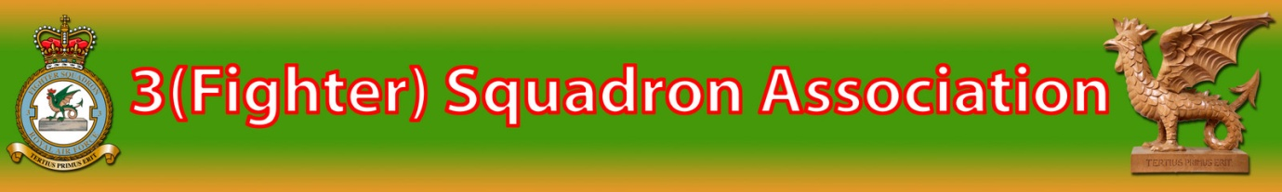
No. 3(F) SQUADRON ASSOCIATION
President: Air Chief Marshal Sir Richard Johns GCB, KCVO, CBE, FRAeS.
To enable past Squadron members to maintain contact an official UK-based Association was formed in 1984. Membership is open to all ranks, of all services, who have ever served on No.3 (F) Squadron since its formation in May 1912. The membership represents all the aircraft types operated by the Squadron since World War II - from Typhoon 1 to Eurofighter Typhoon.
Your subscription finances a Newsletter, which brings news of the Squadron, reunions, reminiscences etc. together with a regularly updated Members' List which has frequently helped to renew lost contacts.
Membership is for the calendar year from 1st April 2019 with applications received after 31st December covering the following full year. The membership fee is £10 payable annually from 1st April via PayPal or bank transfer The PayPal reference is 3fsubs@gmail.com or paypal.me/3fsubs or via bank transfer:
A/C No 02550283 Sort Code: 30-92-33
You are invited to complete an Application Form and return it, together with your subscription details, to:

Mr Phil Willsher
Membership Secretary
No.3(F) Squadron Association

3 Rutland Way

Ryhall

STAMFORD

PE9 4ET
Telephone: 01780 764141
E-Mail: Phil's email
SUBSCRIPTIONS
Annual
UK and BFPO £10.00 Annual Fee via PayPal or via Bank Transfer/Standing Order:

Account No: 02550283 Sort Code: 30-92-33 Payee 3F Squadron Association. Put in the reference your name and membership number.
OVERSEAS ONLY: £10.00 PayPal preferred or Bank Transfer (as above) or Local Banknotes

Please Note: Even though this is now an annual payment, reminders will not be sent out, so the annual fee should be set up to be paid automatically every year.

Please also note: Failure to pay or renew your annual membership fee will mean loss of the newsletter and information about the Association events being sent out via email.
No. 3(F) SQUADRON ASSOCIATION
I wish to join/renew membership for the Association and enclose my subscription details of £10 per annum valid from 1st April 2019 until December 20…. or
(Cheques or PO's made payable to No.3 (F) Squadron Association (overseas members only), please
In return I shall receive a copy of the latest Newsletter and a Members' List (printing when available). On the understanding that it will be available only to current members of the Association, I have no objection to the information provided below being stored on computer.
Signed ..............................................................Date .............................
SURNAME FIRST NAME(S)
DECORATIONS
ADDRESS
TELEPHONE E-Mail
Preferred form of address (Title, Mr, Mrs, Ms or Rank and Decorations)

SERVICE with No. 3(F) SQUADRON
(1) (2) (3)
Date(s)
Base(s)
Aircraft
Role (i.e. Aircrew, Engineer)

